WEEK 1

TRIAD OF SECURITY

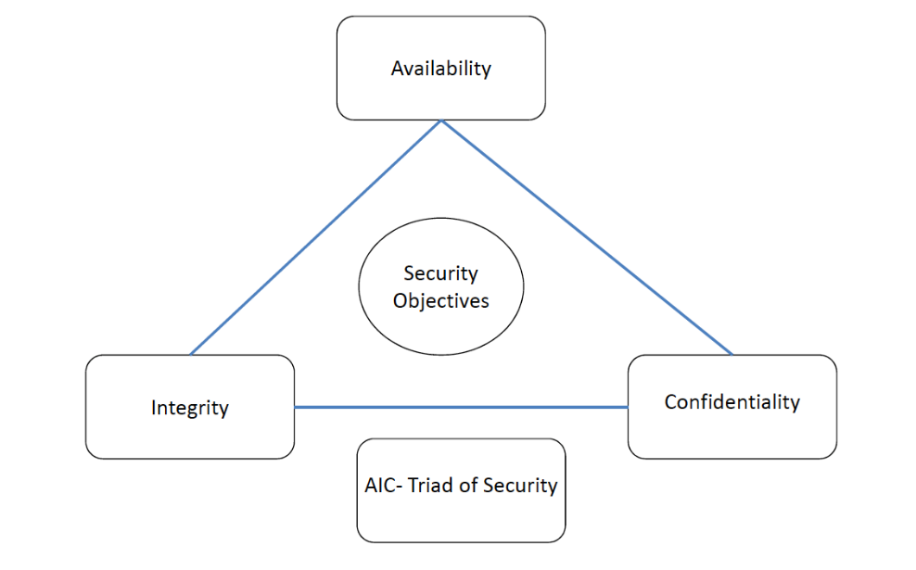

**Availability** Protection ensures **reliability** and **timely** **access** to **data** and **resources** to **authorised** **individuals.**

**Integrity** Is upheld when the **assurance** of the **accuracy** and **reliability** of **information** and **systems** is **provided** and any **unauthorised** **modification** is **prevented**.

**Confidentiality** Ensures that the **necessary** **level** **of** **secrecy** is **enforced** at **each** **junction** of data **processing** and **prevents** **unauthorised** **disclosure**.

This **level** of **confidentiality** should **prevail** while **data** **resides** on **systems** and **devices** **within** the **network**, as it is **transmitted**, and **once** it **reaches** its **destination**.

Controls to Counter Cyber Attack

**Availability**

* Redundant array of inexpensive disks (***RAID***)
* Clustering
* Load balancing
* Redundant data and power lines
* Software and data backups

**Integrity**

* Hashing (data integrity)
* Configuration management (*system integrity*)
* Change control (*process integrity*)

**Confidentiality**

* Encryption for data at rest (*whole disk, database encryption*)
* Encryption for data in transit (*IPSec, SSL, PPTP, SSH*)
* Access control (*physical and technical*)

**Vulnerability** A lack of a **countermeasure** or a **weakness** in a **countermeasure** that is **in** **place**.

**Threat** A threat is **any** **potential** **danger** that is **associated** with the **exploitation** of a **vulnerability**.

**Threat** (*for business*) The threat is that **someone**, or **something**, will **identify** a **specific** **vulnerability** and **use** it **against** the **company** or **individual**.

**Threat Agent** The **entity** that **takes** **advantages** of a **vulnerability** is referred to as a **threat** **agent**.

**Risk** A risk is the **likelihood** of a **threat** **agent** **exploiting** a **vulnerability** and the **corresponding** **business** **impact**.

**Exposure** An exposure is an **instance** of **being** **exposed** to **losses**.

**Control** A **control**, or **countermeasure**, is put into place to **mitigate** the **potential** **risk**.

A **countermeasure** may be a **software** **configuration**, a **hardware** **device**, or a **procedure** that **eliminates** a **vulnerability** or that **reduces** the **likelihood** a **threat** **agent** will be able to **exploit** a **vulnerability**.

Relationship Among Different Security Concepts

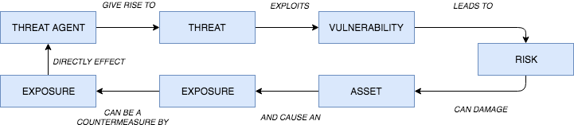

Types of Attack

1. ***INBOUND ATTACKS***

*Scrambling sequence of data packets*

* **Intrusion Detection Systems** rely on packets coming through the network **sequentially** to identify **patterns** or ‘**signatures**’.
* Destination device reassembles packets on the **inside**.

*Encoding*

* Not all IDS signature detection is normalised.
  + E.g. - Unicode-encoding by changing spaces to “**%20**”

1. ***MALWARE***

* Any software that the user of system admin did not authorise or want on their computer.
* *Spyware, grayware, adware, Trojan horses, key loggers, backdoors, rootkits.*
* Once installed, it’s difficult to detect by **intrusion** **detection** **systems** and **firewalls** **rarely limit egress (*outbound*) traffic**.
* Once inside a system, malware can scan for vulnerabilities and exploit them.

*HOW DOES MALWARE GET ONTO A SYSTEM?*

* **Phishing (Social Engineering)**
  + Emails sent to people who are then:
    - Lured into **downloading** **malicious** **software**.
    - Visit a **website** that **infects** the **system**.
    - Gives up **passwords**.
* **Pharming** 
  + Redirecting a websites traffic to another website
    - **DNS poisoning** - modifying a router’s **DNS** **address**.
    - **Modifying** **OS** local **resolution** hosts **file**.
* **Backdoors**
  + **Secret entry points** into a **program** that **bypass** normal **security** **checks**.
  + **Maintenance hooks** are an example of a **legitimate** form of **backdoor**, to debug and test programs.
  + **Logic Bombs** are embedded in programs and are set to **explode** when certain **conditions** are **met**. - Can alter or delete files.
* **Viruses (Self-propagating)**
  + **Attach** to **programs** of files enabling it to spread.
  + Almost always an **EXE** file.
  + Cannot spread without **human** **action**.
  + *Comprise of three parts:*

1. **Infection Mechanism**
   1. *Means by which is spreads.*
2. **Trigger**
   1. *Event or condition that enacts the virus.*
3. **Payload**
   1. *What the virus does.*

TYPES OF VIRUS

*ENCRYPTED VIRUS*

* A portion of the virus **creates** a **random** **encryption** **key** and **encrypts** the **remainder** of the **virus**.
* When the virus is **invoked**, the **key** is **used** to **decrypt** the virus.
* When the virus **replicates**, a **different** **key** is used.
* **Difficult** to **monitor** bit **patterns** of the **virus**.

*STEALTH VIRUS*

* Explicitly designed to **hide** **itself** **from** **detection**
  + *e.g.* ***compressing itself*** *to be the* ***same******size*** *as the* ***program*** *it has* ***infected****, or detecting virus scans and presenting the original version of the program.*

*POLYMORPHIC VIRUS*

* **Mutates** with every **infection** making **signature** **detection** **impossible**.
* **Functionally** the **same** but **bit patterns are different**.

*METAMORPHIC VIRUS*

* As with polymorphic but the **alteration** of **bit pattern** is **even more complex**.
* **Routines** may also **change** so **behaviour as well as** **bit** **pattern** may **change**.

WORMS

* Unlike a virus, **worms can travel without human action**.
* Uses vulnerabilities of the system to **travel unaided**.
* Can **replicate** **many** **times**, **consuming system memory and/or network bandwidth**.
* Code Red worm (*359k MS IIS Web servers in 1 day (July 2001)*)…patch made available 1 year earlier. Costed at $2.62 billion.

TROJAN HORSES

* “**Hides itself**” **as useful software** but actually **does damage once installed**.
* Can **delete files, corrupt information**.
* Also create “**backdoors**”, giving malicious users access to your system.
* **Do not reproduce**, unlike viruses and worms.
* The software may continue to **perform the task you installed it for**, but **behind the scenes** it is **attacking the system**.
* Alternatively, it may be acting maliciously while operating ask expected e.g. collecting passwords and form data.

BOTNETS

* **Zombie** = when a **system gets infected** with malware and **falls under external control**.
* Botnet (*roBOT NETwork*) = collection of zombies under command and control of a hacker.
* Vint Cerf (2007) – Up to 25% of PCs part of a botnet.
* Today there are c.1.2 billion computers on the Internet.
* Feb 2000 – schoolboy brings down Dell, CNN, Amazon, eBay and Yahoo website using 200 university networks in the US to launch distributed denial of service (DDoS) attacks.
* **DDoS** = **hundreds of systems** requesting a new session with a website – servers cannot handle the requests and crash.

HACKNG WEB SERVICES

*Web services act as* ***middleware to connect distributed systems*** *and* ***share data****.*

*Vulnerable to attacks:*

* **Cross-site scripting (XSS)**
  + Attackers “**inject**” **malicious** **scripts** **into** **web pages** (*e.g. posting a message on a social network that includes a script to collect session cookies, hidden inside <script> elements…readers of the message have their cookie stolen*).
* **Cross-site request forgery**
  + **Attackers uses user cookies** (e.g. while logged into bank) to authorize attacks (e.g. transfer money to account X) without user’s knowledge.
* **Browser flaws**
  + A form of **malicious** **code** that takes advantage of a **flaw or vulnerability in an operating system or piece of software** with the intent **to breach browser security** to **alter** a **user's browser settings without their knowledge**.
  + Malicious code may exploit ActiveX, HTML, images, Java, JavaScript, and other Web technologies and cause the browser to run arbitrary code.

SEARCH ENGINE MANIPULATION

*Search engines are manipulated to:*

* **Present false results** that link to malicious sites.
* **Rank malicious** **sites** at the **top** of the **results**.
* **Manipulate** **adverts** to direct to malicious sites.

***Search engines use (secret) page ranking algorithms but word count, result click-thru, and the number of sites linking to a result often supersedes these.***

*Botnets are used to:*

* **Add references to hacked sites** to **boost search engine rankings** of malicious sites.
* Add **keywords** to **pages**, **relating to current** **events**, celeb, political, natural disasters – links to malicious page

Virtualization and the Cloud

Virtual machines now allow **hundreds of instances** of **an operating system** to **run on a single server**.

*What happens if the virtualization software is compromised?*

* Happened in 2009 when over 100,000 websites hosted in a virtual environment were destroyed by a hacker, using a **zero day exploit** to **gain** **root access**.
* Less than half the customers had a full backup.

CONTROL TYPES

***Administrative***

* Commonly referred to as “**soft controls**” because they are **more** **management oriented**.
  + Examples of administrative controls are **security documentation, risk management, personnel security, and training**.

***Technical***

* **Software** or **hardware** components, as in **firewalls, IDS, encryption, identification and authentication mechanisms**.

***Physical***

* Items put into place to protect facility, personnel, and resources.
  + *Examples of physical controls are* ***security guards, locks, fencing, and lighting****.*

FUNCTIONALITIES OF SECURITY CONTROL

**DETERRENT** Intended to **discourage a potential attacker**.

**PREVENTIVE** Intended to **avoid an incident from occurring**.

**CORRECTIVE** **Fixes components** or **systems after** an **incident** has occurred.

**RECOVERY** Intended to bring the **environment** **back to regular operations**.

**DETECTIVE** Helps **identify** an **incident’s activities** and **potentially an intruder**.

**COMPENSATING** **Controls** that **provide** an **alternative measure of control**.

SECURITY METRICS

*Risk can be measures by two ways:*

1. ***Quantitative risk analysis*** 
   1. Used to **assign monetary and numeric values** to **all elements of the risk analysis process**.
2. ***Qualitative risk analysis***
   1. Uses a **“softer” approach** to the **data elements** of a **risk analysis**. It **does not quantify that data**, which means that it **does not assign numeric values** to the data **so that** **they can be used in equations**.